**Version Control of .mlapp Format File: Exporting to .m File:**

1. In “Save” button, click the downward arrow, and click “Export to .m File…”

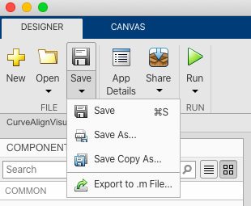

2. Save to a place

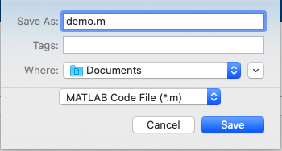

3. Add both the .m file and the .mlapp file to the GitHub repository by clicking the “Add file” on the up right corner and choose “Upload files”

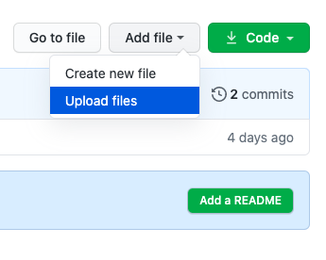

4. Upload both files and commit to change.

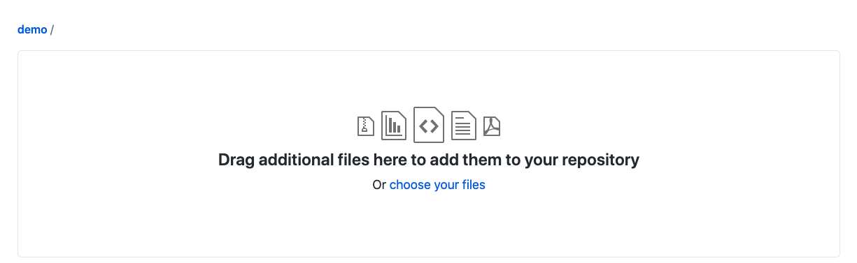

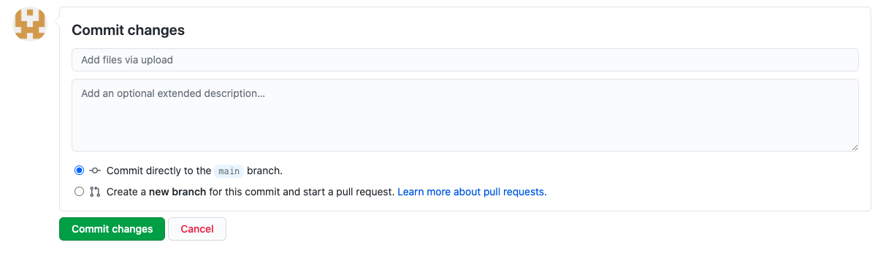

5. Use git clone command to clone the repository to the local computer

6. Make changes as wanted in the .mlapp file in local computer

7. Delete the exported .m file

8. Use the method described in former steps, export the .mlapp file to .m file again, in the same repository, and with the same identical name.

9. Use git add command to choose files to be commited

10. Use git commit command to commit local changes

11. Use git push command to push the changes to the GitHub repository

12. Now in history, the old version and the new version should appear.